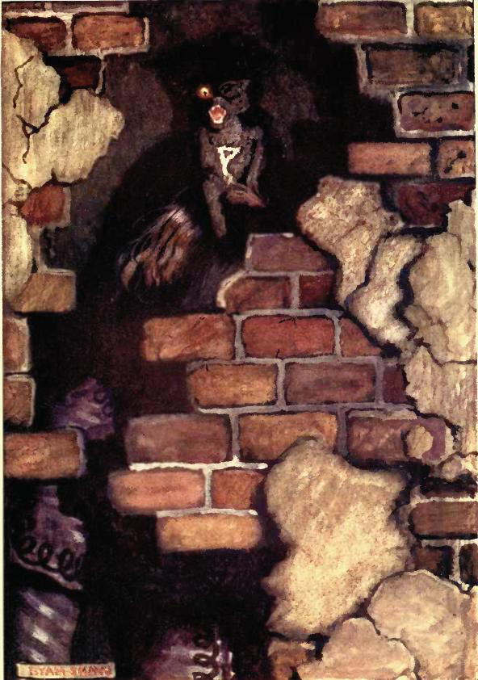
This image has a straightforward but disturbing story behind it. The image is from the short story "The Black Cat" by Edgar Allan Poe when looking at this image what one sees is a black cat and a broken brick wall. But if you look closer and see who the cat is sitting on, it's a woman — the wife of the narrator, who was killed because he was trying to kill his cat. Now the next thing that might come up in your mind is that the narrator never loved his wife if he thought that this was the proper way to handle his problem. Before this cat, the narrator, had another cat named Pluto, who was like his best friend, the man would start coming home drunk, changing his behavior towards his wife and other pets. His behavior towards Pluto didn't change until Pluto became scared of him, afraid that something might happen. He ended up killing the cat and felt nothing; he replaced Pluto quite quickly. He found a cat very similar to Pluto, he didn't have that connection he had with Pluto, but his wife did. His wife was very fond of the cat, which may have bothered the man. The cat may represent the wife, someone who is around you all day, follows you and wants your attention at all times. It could be that the man didn't accidentally kill his wife, one could assume he did it on purpose to get rid of that neediness.

