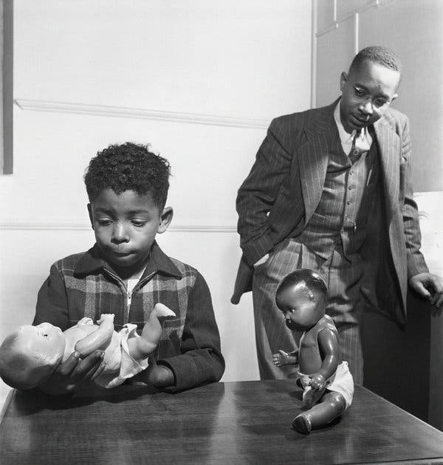
This image is known as ‘the doll test,’ which took place in the 1940s, where white people still had the power of African Americans. As we can see, there is a little boy who is given the option to choose between a white doll or a black doll. The boy picks the white doll because it is a representation of good and beautiful. This standard of beauty that is put up by companies and communities affect African American children because since this is seen as what beauty is, it allows these children to think less of themselves and want to have white characteristics. Now this image goes perfectly with the novel The Bluest Eye by Toni Morrison, the narrator of the story, Claudia, receives a white doll for Christmas. To most parents, they think that every child wishes to have a doll-like that but not Claudia. She doesn’t believe that to be beautiful; one has to white characteristics. However, Pecola, the main character, wants to change her eyes. To Pecola having blue eyes is what makes someone attractive and valued. She is seen being obsessed with Shirley Temple, a white icon. Towards the end of the novel, Pecola drives herself to insanity by seeing herself with blues and having conversations with herself, asking if she has to have the bluest eyes. To Pecola, she feels like to be at the top of the list; she has to have the bluest eyes.

